TITLE OF THE PAPER (Times New Roman, 13 pt, Capitals, Bold, Left alignment)
<13 points> Free space (1 line)
First Name, Name of the author(s) (Times, 11 pt, Bold, Left alignment, Regular), each name being followed by the didactic and scientific degree, the position and place of work of the authors ( e-mail) are indicated, with Times New Roman, Italic, 11 point,.
(11 points) Free space (2 lines)
(11 points)
ABSTRACT: (Times New Roman, Bold, Italic, 10 pt, line spacing: single, Justify. The word ABSTRACT should be followed by a brief presentation of the paper in English, maximum 200 words in Times New Roman, 10 pt, Italic, line spacing: single, Justify) The abstract should be placed above KEYWORDS (up 5 words).
(10 points)
KEY WORDS: (Times New Roman, 10 points, Italic, bold), up to 5 words in English, TNR, 10 points, regular
(10 points)

1. THE TITLE OF THE CHAPTER IS WRITTEN WITH CAPITAL LETTERS, BOLD, TIMES NEW ROMAN, 10 POINTS AND WILL BE NUMBERED WITH ARABIC NUMBERS.
⋅ (10 points) Free space (1 line)
<Tab> The text should be arranged by two columns of 80 mm width and 5 mm spacing between them, TNR, 10 pt, Justify, line spacing: 1 line, tab = 0.5 cm.
<Tab> The paper will be edited in english language on A4 format (210 x 297 mm).
First page of the paper must have the following margins: Top: 5 cm , Bottom: 2 cm, Left: 2.5 cm, Right: 2 cm.
Next pages setup: Top: 2.5 cm, Bottom: 2 cm, Left: 2.5 cm, Right: 2 cm, using MICROSOFT WORD and the number of pages must be even, between 4 and 6, maximum 6 pages.
Free space (1 line)
1.2 Subtitles of the chapters (Times, 10 pt, Bold, Lowercase, Left alignment).
Free space (1 line)
2. EQUATIONS, FORMULAS, SYMBOLS AND MEASURE UNITS:
Free space (1 line)
The equations and formulas are written beginning from the left part of the column, consequently numbered, the reference being made at the corresponding number. Free space (1 line) should be left before and after each equation. Use the ISM notation and the Arabian numbering.

X² + Y² = Z² (1)
Free space (1 line)
2.1. Photos, figures and tables:
Free space (1 line)
Have 80 mm width (one column) or 165 mm (two columns). The figures should be consequently numbered and centered. Figures should be referred in the text closer to paragraph where it makes reference.
Leave free space (1 line) between text and photos.
Free space (1 line)
3. CONCLUSIONS:

These should express the author’s point of view regarding the possibility to apply the results presented in the paper.

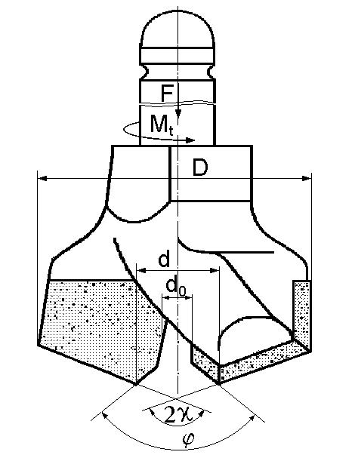
Fig. 1. Detachable bit

The papers should be drawn up in English (other languages are acceptable only for Philology field) and edited in an even number of pages (maximum 6 pages, including annexes and figures). Free space (2 lines)
(10 points)
(10 points)
4. REFERENCES: (Times, Italic, 10 pt, single lines spacing, Left alignment)
Name, initial - title of the paper, publishing house, year.
The references should be written in alphabetical order, being numbered and put in text between brackets
References (will be written according to the model, Times New Roman 10 points).
⋅ (10 points)
- Marian, I., Mecanizarea în minerit, Technical Publishing House, Bucureşti, 1969.
- .

